|  |
| --- |
| First Last |

Humber College Institute of Technology & Advanced Learning DeepRacer Entry 0NB

Status

/1 Hardware present?

/1 Title Page

/1 Declaration of Joint Authorship

/1 Proposal (500 words)

/1 Executive Summary

# Declaration of Joint Authorship

We, Manshur Ramhith, Deval Rajgor, and Abdirashid Yusuf, confirm that this work submitted is the joint work of our group and is expressed our own words. Any uses made within it of the works of any other author, in any form are properly acknowledged at the point of use. From the previous semester each one of us worked individually on our hardware but also, we had to build an APP in CENG319 by working as a group. Thus far, I would say that each and every one of us has been the lead on our own hardware. Therefore, Manshur has worked on the temperature & humidity Sensor, Deval worked on a combination of the luminosity Sensor and the Neopixel Ring and Abdirashid has focused on the audio part by working on the microphone sensor. However, for the software part, we all worked as a group to put together a mobile application which covered the main features that our final project is going to have. For the software, Manshur worked with the database(input & retrieve from it) as well as graphs that display the change in temperature and humidity levels, Deval implemented a color wheel, a feature that is going to be useful for the neopixel ring and Abdirashid worked on the Bluetooth part of our APP(which is needed for the communication). I would also say that we all equally on designing the APP as a whole and the aesthetic aspect of the piece of software.

# Proposal

In one of our previous course CENG319(Software Project), we have created a mobile application that allowed us to work with databases by manually putting data into the database to simulate real time data and retrieve this data at any given time. In CENG 317(Hardware Project), we have prototyped a small embedded system with a custom PCB as well as an enclosure which held our individual Sensor and development platform (mine was both 3D printed & laser cut). In this semester our main aim is to make the hardware and software part work in parallel in order to have a fully functioning model.

Below is a list of the components that we are using:

Development platform: Broadcom Development platform (Raspberry Pi 3B+/4)

Sensor/Effector 1: DHT 22 (Temperature & Humidity Sensor)

Sensor/Effector 2: TSL 2591 (Luminosity Sensor)/ Neopixel Ring

Sensor/Effector 3: SPH 0645LM4H (Microphone Sensor)

Our project will include the use a microphone to detect any noise coming from the room & mainly a temperature and humidity sensor, we also plan on adding a full-duplex communication line for the parents to hear and talk to their kids and maybe also an option that alerts the parents of the condition in the room depending on the temperature and humidity. Moreover, we will have a luminosity sensor that will work with a Neopixel Ring to create an ambiance inside the infant’s room whenever the luminosity level drops below a certain set point. This application will help a lot of parents understand their babies’ needs and will also retrieve the optimum conditions in which the baby has a better sleep. More specifically, the screen of the application will be displaying temperature Degrees Celsius and humidity percentage at any given moment, an open line access to the microphone which will be always on as well as an option to manually set the colors of the Neopixel ring if wanted.

In this semester, we hope to achieve the goal of our Internet of Things (IoT) capstone project that will use a distributed computing model of a smart phone application, a database accessible via the internet, an enterprise wireless (capable of storing certificates) connected embedded system. We also plan to design a new prototype with a new custom PCB as well as an enclosure that will successfully hold the whole of our integrated portable system.

Our physical prototype that we intend to build is to be small and safe enough to be brought to class every week as well as be worked on at home. In alignment with the space below the tray in the Humber North Campus Electronics Parts kit the overall project maximum dimensions are 12 13/16" x 6" x 2 7/8" = 32.5cm x 15.25cm x 7.25cm.

# Executive Summary

This app combines all the functionalities of light, temperature/humidity and sound to ensure that parents have absolute control over the conditions in which their babies are living in. The app has been tested with sample data at the moment from firebase. However, for this semester, we plan on implementing the sensors with the app to get the data directly from them which will put the readings into the database. Moreover, as we already have the Bluetooth connection working, we only have to send the voice over the channel as a part of this semester’s implementation. I feel that our APP will revolutionize the realm of baby monitors because as of today I don’t think that there is any product currently available with the features that we are offering. I also feel that our product will attract a large range of customers as they will be able to keep track of the perfect conditions for their babies to sleep in and stay comfortable.

Contents

Declaration of Joint Authorship 3

Proposal 5

Executive Summary 6

List of Figures 11

1.0 Introduction 13

1.1 Scope and Requirements 14

2.0 Background 17

3.0 Methodology 19

3.1 Required Resources 19

3.1.1 Parts, Components, Materials 19

3.1.2 Manufacturing 19

3.1.3 Tools and Facilities 19

3.1.4 Shipping, duty, taxes 21

3.1.5 Time expenditure 21

3.2 Development Platform 22

3.2.1 Mobile Application 22

3.2.2 Image/firmware 23

3.2.3 Breadboard/Independent PCBs 24

3.2.4 Printed Circuit Board 26

3.2.5 Enclosure 27

3.3 Integration 28

3.3.1 Enterprise Wireless Connectivity 29

3.3.2 Database Configuration 29

3.3.3 Security 29

3.3.4 Testing 29

4.0 Results and Discussions 31

5.0 Conclusions 33

6.0 References 35

7.0 Appendix 37

7.1 Firmware code 37

7.2 Application code 37

# List of Figures

Figure 1. By Android Studio - https://developer.android.com/studio/, CC BY-SA 4.0, https://commons.wikimedia.org/w/index.php?curid=74094999 23

Figure 2. Initial schematic. This work is a derivative of "http://fritzing.org/parts/" by Fritzing, used under CC:BY-SA 3.0. 25

Figure 3. This work is a derivative of "http://fritzing.org/parts/" by Fritzing, used under CC:BY-SA 3.0. 25

Figure 4. Breadboard prototype. 26

Figure 5. PCB design This work is a derivative of "http://fritzing.org/parts/" by Fritzing, used under CC:BY-SA 3.0. 27

Figure 6. Humber Sense Hat Prototype PCB. 27

Figure 7. Example enclosure. 28

Figure 0. Gantt Chart for project implementation…………………………………………21

# 1.0 Introduction

The Lumi monitor is designed to help young and overwhelmed parents by easing the hardships of parenting. With the use of a simple GUI, the aim for our application will be to enable parents to pay attention to their baby via a hardware installed in a baby’s room which will include two-way audio communication, sensors that track room temperature and humidity as well as a light and luminosity control. The Lumi monitor allows parents to monitor and understand their baby’s daily development around the clock. Our product can be viewed as an ameliorated approach on baby monitors and will definitely revolutionize the realm of baby monitors as we are not only implementing a voice channel like most baby monitors but also a way of keeping track of the perfect conditions for babies to sleep in and stay comfortable. Our project will target three major issues which are:

• Adjusting the appropriate living conditions inside the baby’s room. (Temp & Humidity)

• Setting an appropriate theme in the baby’s room.

• Communication.

The intent of this APP is to ease the life of parents by keeping track of the living conditions of their infants and ensuring the safety and comfort of their baby through the installation of an integrated hardware in the baby’s room. In this project we will use three sensors and one effector namely: Tsl2591(light sensor) along with a Neopixel ring (LED strip), DHT22 (temperature & Humidity), SPH0645LM4H (Microphone). This project is unique since it allows parents to use a variety of functionalities through an Android app with a friendly User interface. The main development platform that we will use to implement the project is the Raspberry pi. The purpose of this project is to make the life of parents as easy as possible as well as convenience and ease of access to vital information for parents about their babies. With the help of our application, parents will be able to get access to a history of the levels of temperature and humidity for a set amount of days. This information as well as a bunch of other relevant ones will be stored on a database which will be automatically updated using our sensors. Communication will also be possible as the hardware installed in a baby’s room which will include two-way audio communication interface. Moreover, with light and luminosity control from within our APP, parents will be able to adjust the lighting of the room to their liking. Therefore, our product can be viewed as an ameliorated approach on baby monitors and one of the most advanced baby monitors as we are not only implementing a voice channel like most baby monitors but also a way of keeping track of the perfect conditions for babies to sleep in and stay comfortable. It is therefore safe to say that the Lumi monitor allows parents to not only monitor and understand their baby’s development around the clock but also customize parts of this process to their liking. In the scope & requirements section, we will cover what we need in order to complete this project and also what need to be changed from what we already have.

## 1.1 Scope and Requirements

Currently we have the hardware and the software apart. The project prototype is connected embedded system prototype with a custom PCB as well as an enclosure 3D printed. We will connect three sensors to a single PI. With this connection to the Raspberry Pi, we would implement code that would allow a connection to our real-time database and upload the data of each sensor to its corresponding heading of the data structure. With this data uploaded, it would allow for real-time retrieval within the application that would show the changes through time. The data that would be retrieved from our sensors would be the Temperature & Humidity (Acquired by DHT22), the Light Level (Acquired by TSL2591). The other sensor that we plan to implement in our project is the microphone (SPC0645). However, for this sensor, the connection will be done through Bluetooth and therefore not require a spot in the database. As for our effector the Neopixel Ring, the data will be chosen and coming from the user of the APP as compared to the sensors. We are not considering to take the project to CSA for testing because it is only for course completion and graduation purposes only.

# 2.0 Background

We would like to thank mentor Diego Magalhães from AWS for supporting this project. This section is to include at least three references, here is an example of an APA citation of a website (OACETT, 2017) followed by a sentence citing an Article in a Periodical, a Book, and a Journal Article. Humber is planning to host an internal DeepRacer event using an existing example of machine learning (Robuck, 2018), artificial intelligence (Media, O., 2019), and internet connected servers (Kinsella, 2019).

# 3.0 Methodology

This Section will discuss how we plan on implementing our project by making use of various facilities, tools and materials. It will also cover how we plan on purchasing any new parts required to reach the ultimate goal of this project. An idea of our planned time expenditure is also given in this section.

## 3.1 Required Resources

Report

/1 Parts/components/materials (500 words)

/1 PCB, case (500 words)

/1 Tools, facilities (500 words)

/1 Shipping, duty, taxes (250 words)

/1 Working time versus lead time (250 words)

### 3.1.1 Parts, Components, Materials

### 3.1.2 Manufacturing

### 3.1.3 Tools and Facilities

In this segment, we will be discussing what tools/ facilities that we intend to use in order to achieve our final goal for this project. First of all, a vast majority of facilities are available for us here on campus at Humber College North Campus. As you already know, we are going to have to design a new case and a new printed circuit board for our final project. We intend on using the services that are available here at Humber in order to do so. As we are already familiar with these facilities available here having used them in order to complete our Hardware Project course last semester, we hope that having to use them again this semester will be much easier. To begin with, the case will be designed using a special piece of software called Corel Draw which will help us save time whenever we design our acrylic enclosure. After designing our desired acrylic piece, we will have to get the latter printed in the prototype Lab using a special printer/laser cutter found in J20X. Moreover, as per the requirement, we are supposed to also have a 3D printed piece of the enclosure. This will once again imply using the tools and facilities that we are already familiar with. For last semester’s project, I designed the bottom part of my enclosure and got it printed using the 3D printer at the “Idea Lab” found on the 3rd floor of the Learning Resource Commons here at Humber College. For this semester, we plan on doing the same but this time our design will hopefully be different as we are combining our 3 individual projects into one, which will require a more sophisticated case.

As for the Printed circuit board, we will have to design a new one which will accommodate our three sensors and one effector. In order to achieve this goal, the designing process will either be done on Fritzing software or by an online circuit builder. This design will then be tested on our breadboards which are available from our tool kits and same goes for any resistors/capacitors or transistors which will be required to build/test a safe and functioning circuit. Upon successful completion of this task, we will proceed to designing the Printed Circuit Board to replace the breadboarded connection and functionalities. When this step is completed, we will send the required files (Gerber files) to the prototype lab in order to get the PCB printed. We will then proceed to connecting our hardware to the Printed Circuit Board and then to our Development Platform which will be the Broadcom Development Platform also known as the Raspberry Pi. If ever, we are not able to complete one of the above tasks on our own, we are also allowed to involve a third-party company which might help us achieve our goals faster and more efficiently. As for any other physical tool required during testing/development, we believe that our parts kit will contain most of them. Having said all of the above, we still have to keep in mind that our final product has to fit underneath the tray in the Humber North Campus Electronics Parts kit which has the following dimensions 12 13/16" x 6" x 2 7/8" = 32.5cm x 15.25cm x 7.25cm

### 3.1.4 Shipping, duty, taxes

Done by abdi.

### 3.1.5 Time expenditure

This Section will expand on how we plan on allocating our time throughout the implementation and development of this project. Lead time measures the off-time when one is usually waiting or thinking/designing new ideas. For example, the time elapsed from the point a piece of hardware such as a Printed Circuit Board is requested to the point that it’s delivered. Lead time also involves reporting problems such as defective hardware and usually ends when the desired piece has been delivered. On the software side of things, reflection upon implementation of a new functionality might be an example of lead time. On the other hand, working time represents the actual amount of time we will spend developing the app or assembling the hardware. This work time will also include hours spent in the labs soldering, laser cutting, 3D printing and so on. We have decided to create a Gantt chart for better time management on our project. Please find a schedule breakdown down below (Lead time omitted except reading week):

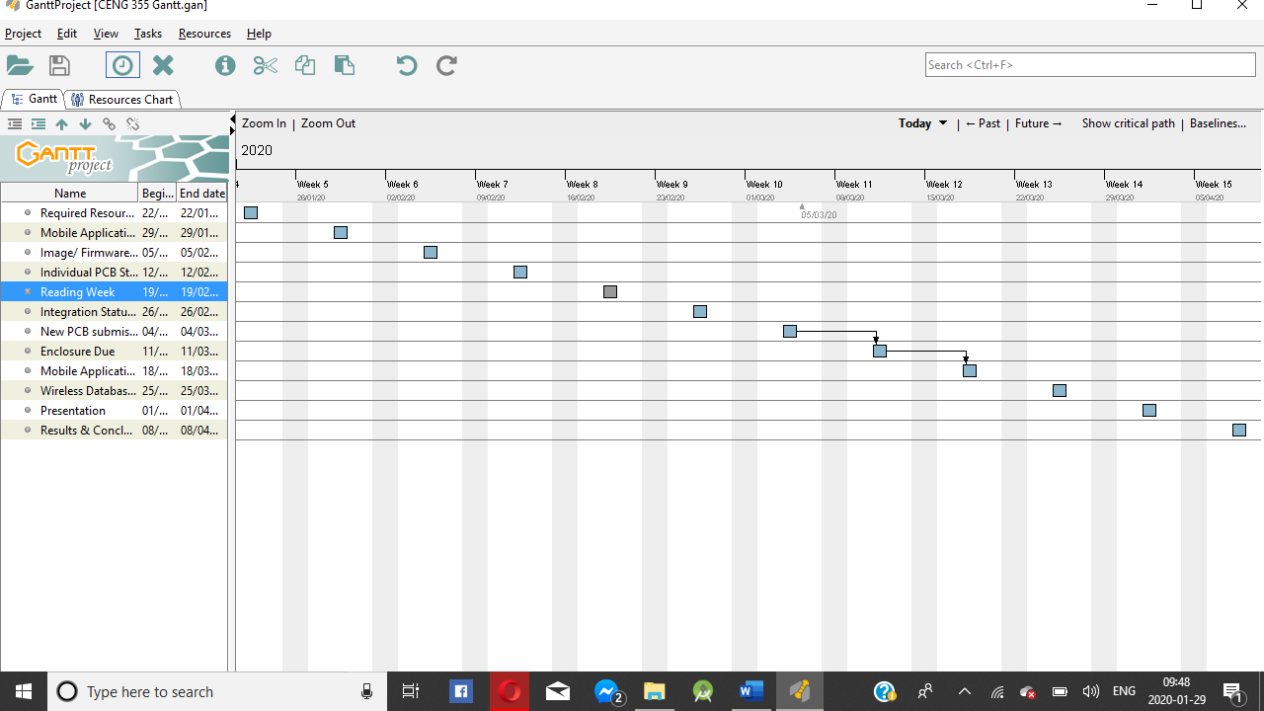

Figure 0. Gantt Chart for project implementation.

## 3.2 Development Platform

### 3.2.1 Mobile Application

Status

/1 Hardware present?

/1 Memo by student A + How did you make your Mobile Application? (500 words) –Should include: Screenshots of the app working.

/1 Data visualization activity – Graph

/1 Action control activity –

Include screenshots such as Figure 1. Testing. Progress.

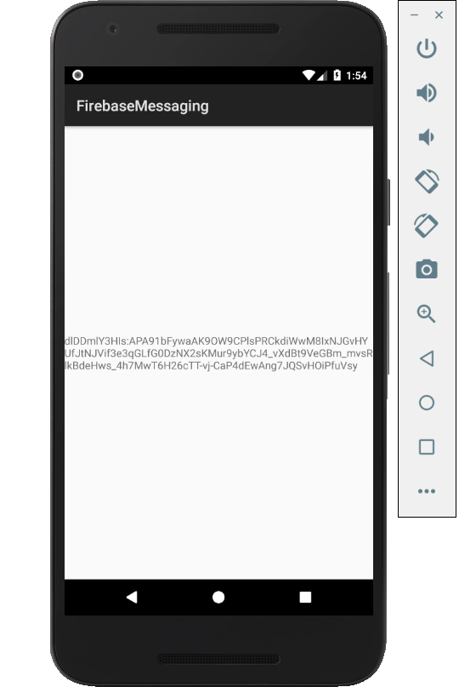

Figure 1. By Android Studio - https://developer.android.com/studio/, CC BY-SA 4.0, https://commons.wikimedia.org/w/index.php?curid=74094999

### 3.2.2 Image/firmware

Status

/1 Hardware present?

/1 Memo by student B + How did you make your Image/firmware? (500 words)

/1 Code can be run via serial or remote desktop

/1 Wireless connectivity

/1 Sensor/effector code on repository

### 3.2.3 Breadboard/Independent PCBs

Status

/1 Hardware present?

/1 Memo by student C + How did you make your hardware? (500 words)

/1 Sensor/effector 1 functional

/1 Sensor/effector 2 functional

/1 Sensor/effector 3 functional

The initial schematic design, Figure 2, based on datasheets (Bosch Sensortec, 2019) led to a breadboard layout Figure 3 that was realized Figure 4.

How did you build your Prototype: Breadboard?

Then a PCB was designed, Figure 5, and populated (Figure 6). Bill of Materials, Case, Time commitment. Testing. Progress.

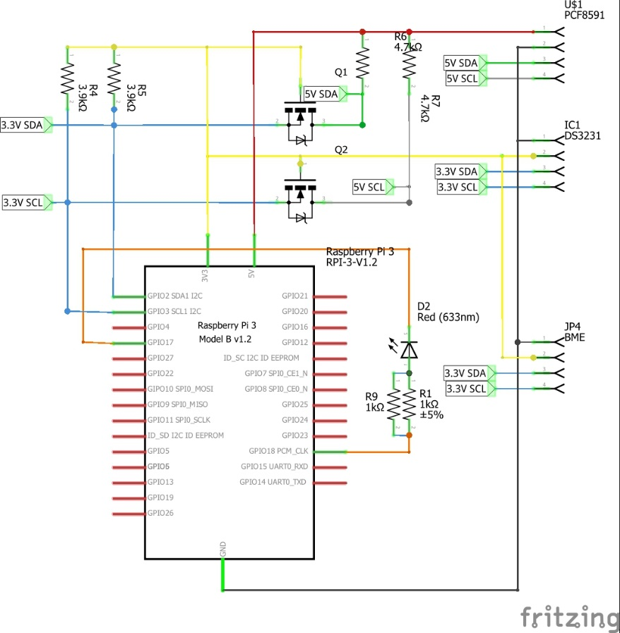

Figure 2. Initial schematic. This work is a derivative of "http://fritzing.org/parts/" by Fritzing, used under CC:BY-SA 3.0.

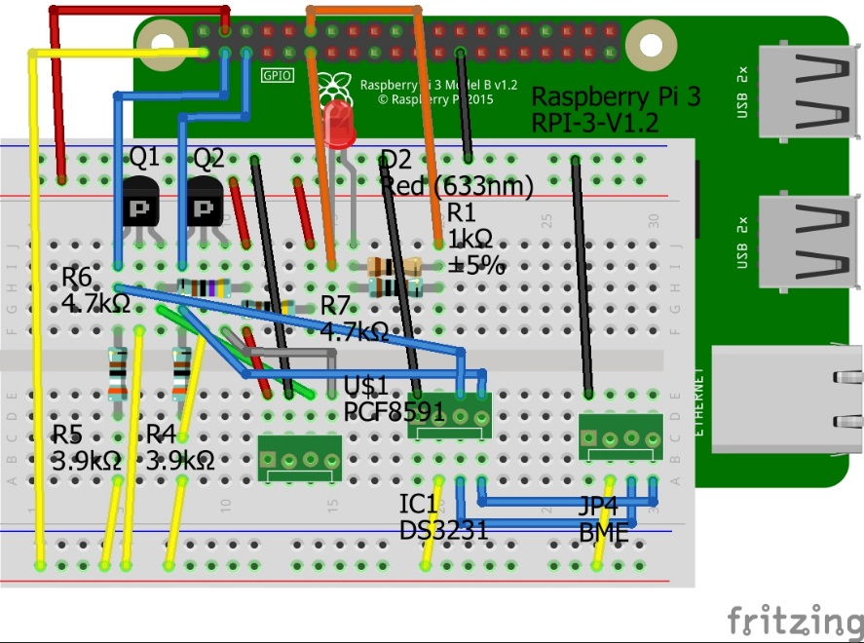

Figure 3. This work is a derivative of "http://fritzing.org/parts/" by Fritzing, used under CC:BY-SA 3.0.

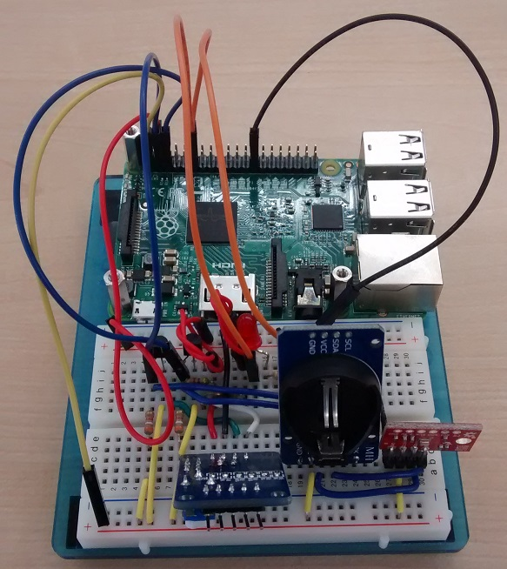

Figure 4. Breadboard prototype.

### 3.2.4 Printed Circuit Board

Demo

/1 Hardware present?

/1 PCB Complete and correct

/1 PCB Soldered wire visible but trim, no holes or vacancies

/1 PCB Tested with multimeter

/1 PCB Powered up

How did you build your Prototype: PCB?

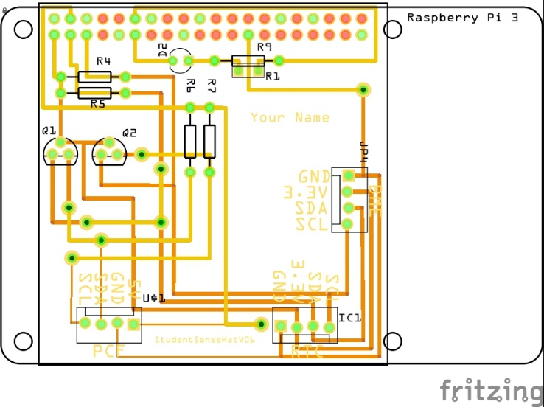

Figure 5. PCB design This work is a derivative of "http://fritzing.org/parts/" by Fritzing, used under CC:BY-SA 3.0.

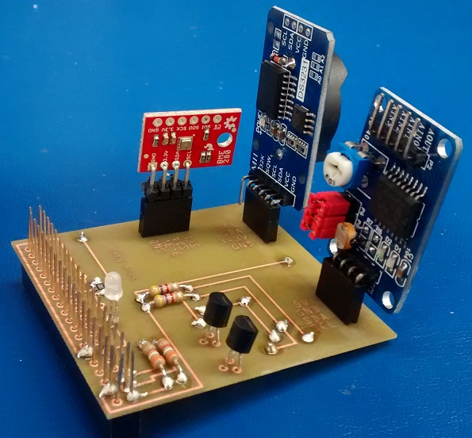

Figure 6. Humber Sense Hat Prototype PCB.

### 3.2.5 Enclosure

Demo

/1 Hardware present?

/1 Case encloses development platform and custom PCB.

/1 Appropriate parts securely attached.

/1 Appropriate parts accessible.

/1 Design file in repository, photo in report.

How did you build your Prototype: Case?

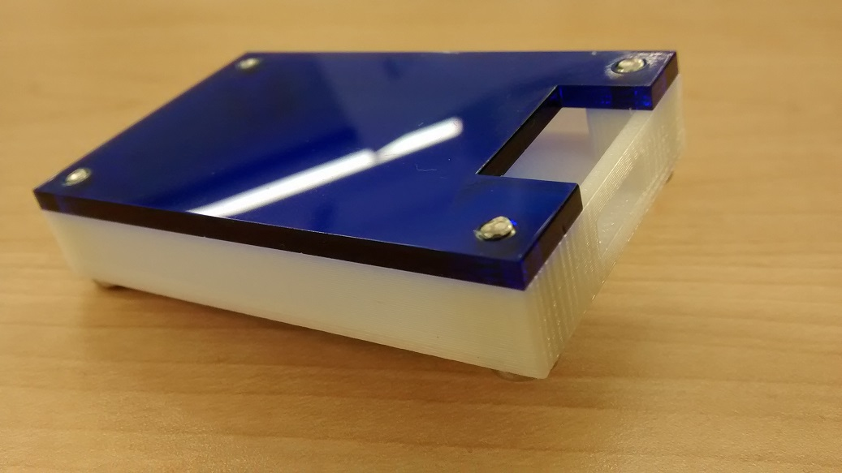

Figure 7. Example enclosure.

## 3.3 Integration

Demo

/1 Hardware present?

/1 Data sent by hardware

/1 Data retrieved by mobile application

/1 Action initiated by mobile application

/1 Action recieved by hardware

Report

/1 Enterprise wireless connectivity (250)

/1 Database configuration (250 words)

/1 Security considerations (500 words)

/1 Unit testing (900 words)

/1 Production testing (100 words)

### 3.3.1 Enterprise Wireless Connectivity

How did you make a Database accessible by both your Prototype and Mobile Application?

### 3.3.2 Database Configuration

### 3.3.3 Security

### 3.3.4 Testing

Unit testing and Production testing.

# 4.0 Results and Discussions

Is your prototype perfect? What did you learn?

# 5.0 Conclusions

If you were making 1000 of these.

Report

/1 Hardware present?

/1 Checklist truthful

/1 Valid Comments

/1 Results and Discussion (500 words)

/1 Conclusion

# 6.0 References

Bosch Sensortec. (2019, July). *BME680 - Datasheet.* Retrieved from Robert Bosch GmbH: https://ae-bst.resource.bosch.com/media/_tech/media/datasheets/BST-BME680-DS001.pdf

Kinsella, J. (2019). Five trends predicted for the cloud industry in 2019. *Software World*, 50(1), 11.

Media, O. (2019). *O'Reilly artificial intelligence conference 2019 - San Jose, California.* California: O'Reilly Media, Inc.

OACETT. (2017, March). *I need to Complete a Technology Report*. Retrieved from The Ontario Association of Certified Engineering Technicians and Technologists: https://www.oacett.org/Membership/Technology-Report-and-Seminar

Robuck, M. (2018, 11). AWS goes deep and wide with machine learning services and capabilities. *Fierceinstaller*.

# 7.0 Appendix

## 7.1 Firmware code

Demo

/1 Hardware present?

/3 Code runs concurrently for all sensors/effectors

/1 Project repository contains integrated code

Status

/1 Memo including updates

/1 Financial update

/1 Progress update

/1 Modified Code Files in Appendix

/1 Link to Complete Code in Repository

## 7.2 Application code

Demo

/1 Hardware present?

/1 Memo by student A

/1 Login activity

/1 Data visualization activity

/1 Action control activity

Report

/1 Login activity

/1 Data visualization activity

/1 Action control activity

/1 Modified Code Files in Appendix

/1 Link to Complete Code in Repository